23.39: a) The electric field outside the shell is the same as for a point charge at the center of the shell, so the potential outside the shell is the same as for a point charge:
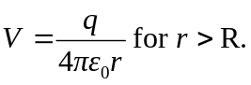
The electric field is zero inside the shell, so no work is done on a test charge as it moves inside the shell and all points inside the shell are at the same potential as the surface of the shell: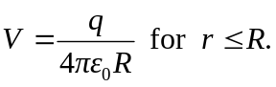
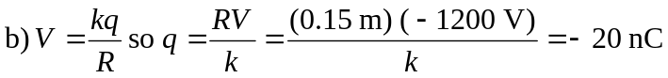
c) No, the amount of charge on the sphere is very small.

